**3.4 Comunicating with the Chariot by Wi-Fi**

In competitions we are only allowed to communicate with the chariot to Start and Stop the Autonomous Motion and to receive telemetry back from the robot for monitoring, display and analysis purposes. In development, however, we can have full two-way communication with a ground station. This could be another R-Pi, laptop, tablet or smart phone. The Autonomous kit has two Raspberry Pi 3s to do this communications task

The Raspberry Pi 3 has built in Wi-Fi and Bluetooth, but we are going to use Wi-Fi to communicate as it is more reliable in a crowded environment.

The **‘Chariot’ R-Pi** should already be configured as a Wi-Fi Hotspot/Server. To communicate, a second **‘Communications’ R-Pi** has to be configured as a Wi-Fi Slave/Client. The default SD card provided will work in both R-Pi s, but comes in the default ‘Hotspot’ mode.

**Configure The Chariot R-Pi as a Hotspot**

The Chariot R-Pi comes already configured as a Wi-Fi Hotspot/Server. You can identify it is in this configuration by looking at the communications icon near the top right corner of the screen which should show two computer screens with three white dots in each screen.

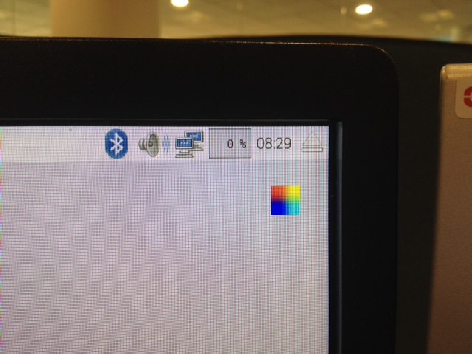

**R-Pi Configured as a Hotspot/Server**

**If In Hotspot Mode**

1. Shut down the ‘Chariot R-Pi’ and remove the HDMI cable, keyboard and mouse cables. Plug in the Chariot power cable and switch on the sensors power and R-Pi power switches to re-boot the Chariot Pi in Hotspot mode as an untethered vehicle.

**If Not in Hotspot Mode**

1. Reconfigure the Chariot R-Pi as described in steps (3) to (5) below:
2. From Desktop > Enter ‘Network-Switch’ folder > Double click on switcher.sh
3. Click “Execute in Terminal” and you should get the screen below

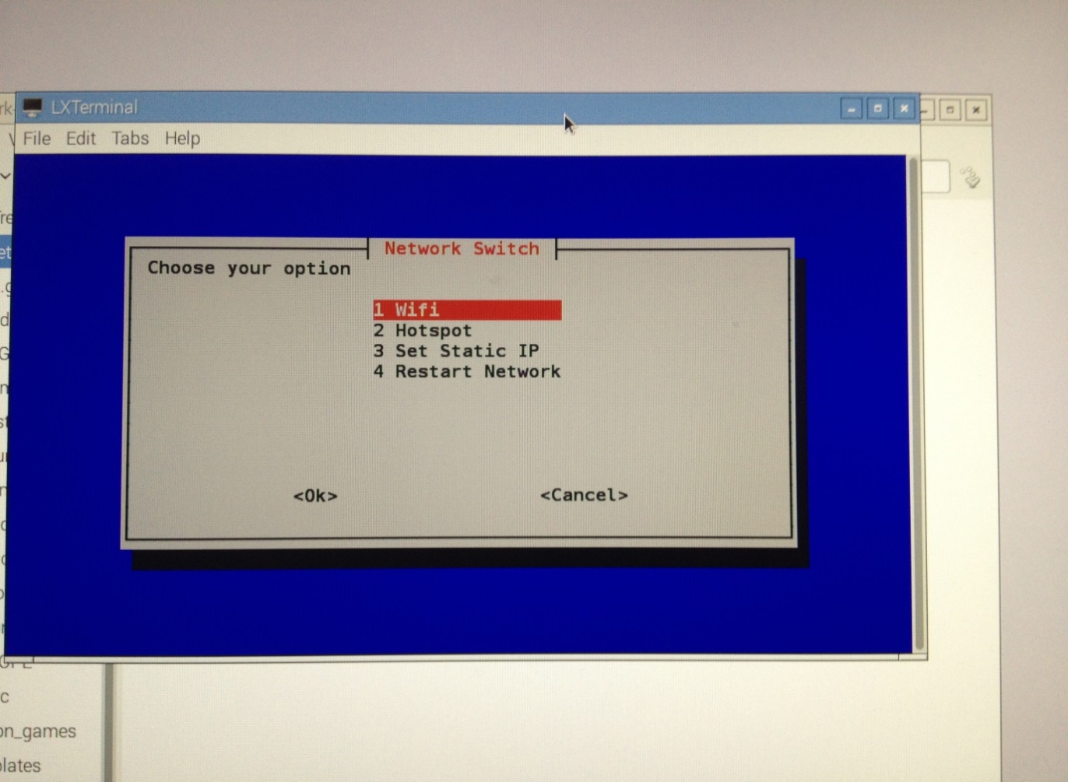

1. Move up and down with the Arrow keys to select **Hotspot** and press Enter.

After a pause, you should see an icon at the top right of the display change to the two computer screens. Each screen has three white dots to indicate signals are being sent out.

**Configure the Communications R-Pi as a WiFi Slave/Client**

The first time you boot up the Communications R-Pi it should be in Hotspot/Server configuration and you will need to reconfigure it as a WiFi Slave/Client. On subsequent booting it should configure in the WiFi mode.

1. Plug the Universal Power Supply cable, HDMI cable, keyboard and mouse cables into the ‘**Communications R-Pi’.**
2. Identify the WiFi configuration by looking at the communications icon near the top right corner of the screen.

When connected by WiFi the Communications R-Pi will show 3 concentric arcs.

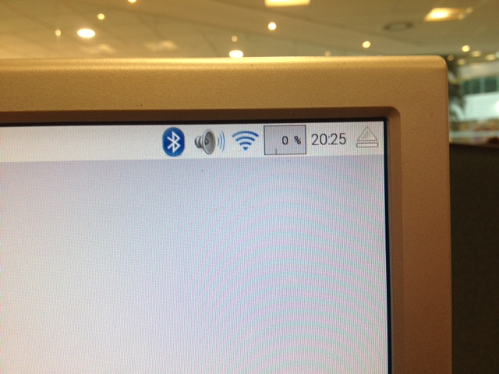

**WiFi Configuration Connected**

When disconnected it will show two computer screens with a box containing a black cross.

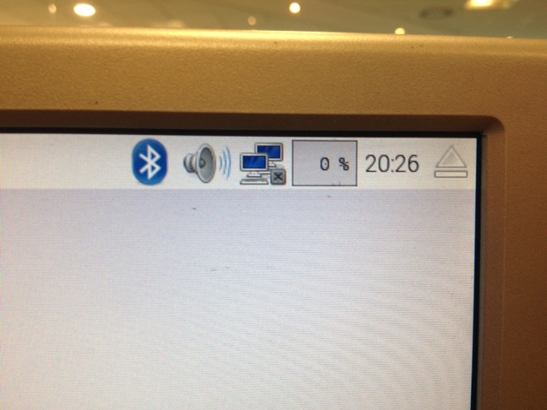

**WiFi Configuration Disconnected**

**If Not In WiFi Mode**

1. From Desktop > Enter Network-Switch folder > Double click on switcher.sh
2. Click “Execute in Terminal” and you should get a visual screen
3. Move up and down with the Arrow keys to select WiFi and press Enter
4. Then click OK to confirm selected option, then after a few second you sure either have the two screens with a cross in a box or the concentric arcs icon (in the top right hand corner).

**If In WiFi Mode**

1. Check that Communications R-Pi is connected to Chariot hotspot R-Pi
2. Click on icon in top right hand corner (either shown as 3 concentric arcs or 2 computer screens next to a box with an X in it)
3. A dropdown should appear with RPiHotspot on it. Check that there is a green tick next to RPiHotspot
4. If no green tick, select the RPiHotspot mode. A box should appear asking for a Pre Shared Key. For this enter ‘raspberry’ and press OK

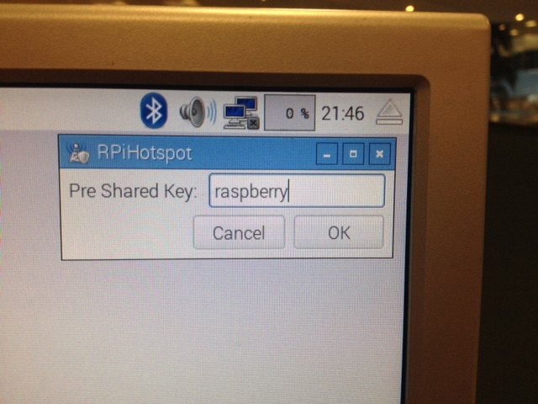

1. If you had 2 screens with a cross before it should have changed to 3 concentric arcs now. The communications R-Pi is now connected to the chariot R-Pi.
2. If problem occurs like RPiHotspot not showing in dropdown, or failure to connect after Pre Shared Key entered. Then check that the Chariot Pi is up and running with green light flashing and then reboot the Communications Pi. Then try entering the Pre Shared Key again.

**Connect VNC Viewer to make Communications R-Pi Screen Display the Chariot R-Pi Screen**

1. From Desktop > Enter Network-Switch folder > Double click on vncconnector.sh

This should run vnc viewer and cause a new screen to appear within your existing one that represents the chariot pi. Anything run on this screen will affect the chariot pi.

The Chariot R-Pi will be running the robot systems, but the ‘Communications R-Pi should now provide the interface to the Chariot R-Pi for development and control. On your monitor the Chariot R-Pi GUI (identified by the two computer screen icon) should be in a window on top of the Communications R-Pi GUI (identified by the concentric arcs icon).

1. Load the test file **MotorTest.py** and confirm the motors can be controlled via the Communications R-Pi over the WiFi.